**PROJECT REPORT**

**ON**

**SOCIETY**

**MANANGEMENT**

**-By**

**Shaikh Maroof.**

**MCA (VESIT-2016-19).**

**Table of Contents**

|  |  |
| --- | --- |
| **Sr.No** | **Topic** |
| 1 | Introduction. |
| 2 | Modules |
| 3 | Testing. |
| 4 | Screenshots. |
| 5 | Conclusion. |
| 6 | Bibliography. |

1. **INTRODUCTION**

**> About the Society**

A society is a group of individuals involved in persistent social interaction, or a large social group sharing the same geographical or social territory, typically subject to the same political authority and dominant cultural expectations. Societies are characterized by patterns of relationships (social relations) between individuals who share a distinctive culture and institutions; a given society may be described as the sum total of such relationships among its constituent of members. In the social sciences, a larger society often exhibits stratification or dominance patterns in subgroups.

Societies construct patterns of behavior by deeming certain actions or speech as acceptable or unacceptable. These patterns of behavior within a given society are known as societal norms. Societies, and their norms, undergo gradual and perpetual changes.

**2 . MODULES**

1. **LOGIN PAGE.**

The initial page of the website. The member logs in from here and proceed to the home page.

1. **HOME PAGE.**

It is the main page of the website. From here Members can visit different pages.

**C) ADD MEMBERS.**

In this Module admin can add different members who are willing to join the society.

**D)NEWLY ADDED MEMBER.**

Here a warm welcome image is displayed for those who have been successfully joined the society.

1. **COMPLAINTS.**

Only members that have joined the society can log a complaint to the admin.

Complaints may be regarding a person,facilities,scams,burglar,others etc.

1. **FACILITIES.**

Types of facilities provided by the society is displayed in this module in the form of Images.

1. **IMPROVEMENTS.**

This is the important Module when discussing about Society Management.

How we can manage our society. What steps we can take to make a better and healty society. Members that are added can suggest something good and innovative in order to improve the society.

1. **LOGOUT**

Members can logout by clicking on the logout button and it redirects on the Login page.

1. **NOTICES**

Any notice regarding the law or other rules are displayed in this Module.

3. **TESTING.**

1. **UAT**

A simple user acceptance testing is done to test the functionality,working and robustness of the Website.

1. **SCREENSHOTS**

1. **LOGIN PAGE.html**

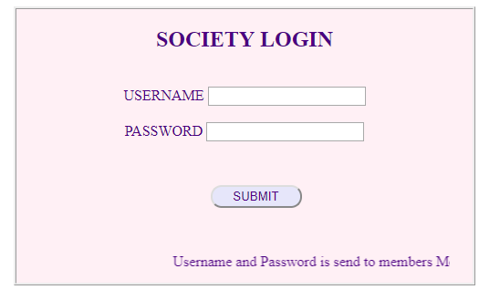

1. **HOME PAGE.html**

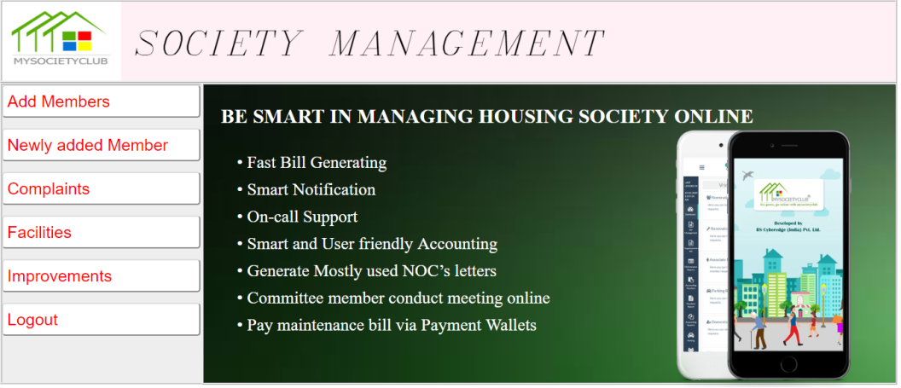

1. **ADD MEMBERS.html**

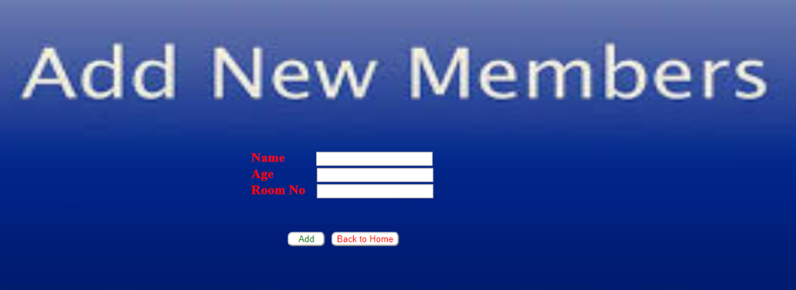

1. **NEWLY ADDED MEMBER.html**



1. **COMPLAINTS.html**

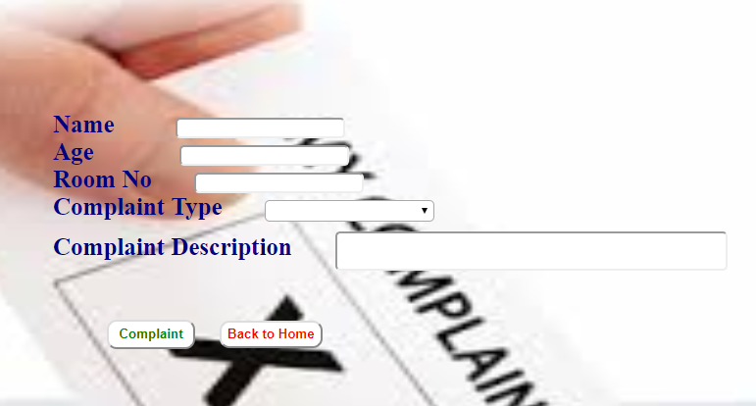

1. **FACILITIES.html**

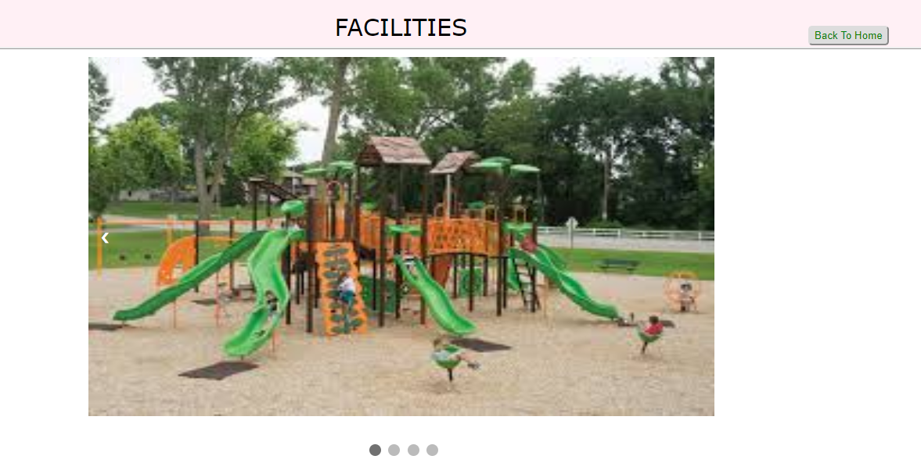

1. **IMPROVEMENTS.html**

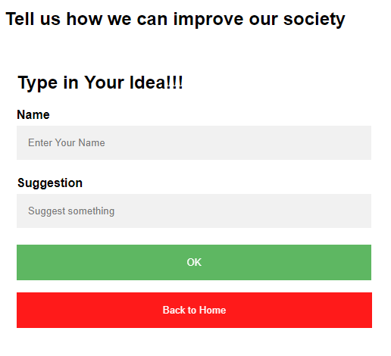

1. **NOTICES.html**

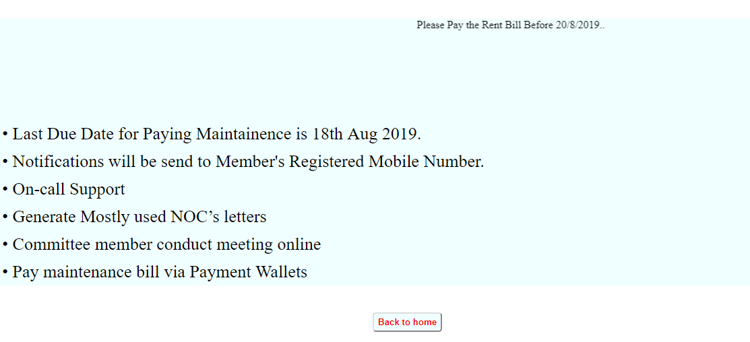

1. **CONCLUSION**

Finally a good society is required for good nature, the people staying over there, services provided to them and safety is the main aspect.

1. **BIBLOGRAPHY**

[www.w3schools.com](http://www.w3schools.com)

[www.stackoverflow.com](http://www.stackoverflow.com)